**Name:Gaurav Kishor Patil**

**Roll No:54 Batch:C**

**Div:2**

|  |
| --- |
| Experiment No. 3 |
| Implement given Boolean function using logic gates in SOP and POS forms. |
| Date of Performance:09/08/23 |
| Date of Submission:16/08/23 |

**Aim -** To implement the given Boolean function using logic gates in SOP and POS forms.

Two input SOP - A.B + A’.B’

Two input POS: - (A+B) (B+C) (A+C’)

**Objective:**

1. Understand how to use the breadboard to patch up, test your logic design and debug it.
2. The principal objective of this experiment is to fully understand the function and use of logic gates
3. Understand how to implement simple circuits based on a schematic diagram using logic gates.

**Components required -**

1. IC’s 7404. 7408, 7432

2. Bread Board.

3. Connecting wires.

**Theory-**

**SOP: -** It is the Sum of product form in which the terms are taken as 1. It is denoted in the K-map expression by sigma ( ∑ )

**Circuit Diagram -**

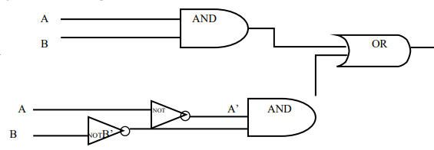

**Truth Table**

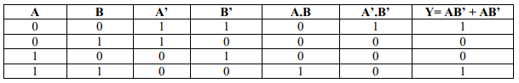

**Procedure -**

**SOP form: - A.B + A’.B’**

1. Place the Digital lab kit at one place.

2. Take the one AND gate ICs i.e. IC no.7408, one NOT gate IC i.e. IC no. 7404 and one OR

gate IC i.e. IC no. 7432.

3. Place these 3 ICs in the breadboard one by one.

4. Now, connect the AND gate with the inputs of A and B and other AND gate in the same

IC is given by the complement input of the A and B i.e. A’ and B’ by using NOT gate with

the help of connecting wires.

5. Give the output voltage Vcc and GROUND to all the ICs separately.

**POS: -** It is the product of the sums form in which the terms are taken as 0. It is denoted in the K-Map expression by the Sign pie ( π )

**Circuit Diagram -**

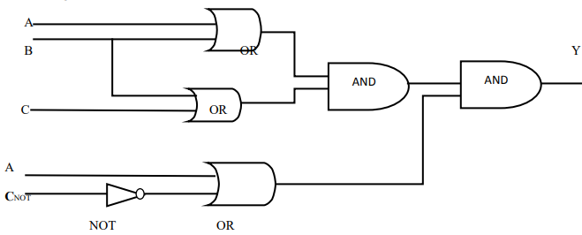

**Truth Table -**

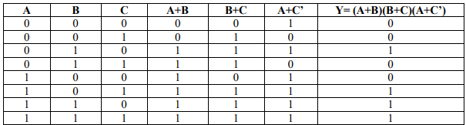

**Procedure**

**POS form :- (A+B)(B+C)(A+C’)**

1. Place the Bread board at one place.

2. Take 1 OR, 1 AND, 1 NOT gates IC.

3. Place these 3 ICs in the breadboard one by one.

4. Now, connect the OR gate of input A or B, B or C and last one is A or C’ (i.e. complement

of C using NOT gate. Inputs are connected with the help of connecting wires.

5. When whole circuit is complete, ON the switch and note down the output with different

values of A, B and C.

**Conclusion -**

To implement a Boolean expression using logic gates, we need to first convert the expression into a sum-of-products (SOP) or product-of-sums (POS) form. Once we have the expression in SOP or POS form, we can use basic logic gates such as AND, OR, and NOT gates to implement the expression. For example, to implement the Boolean expression F = A’B + AB’, we can first convert it into SOP form as F = A’B + AB’ = (A’ + B’)(A + B), which can be implemented using two AND gates and one OR gate. The inputs A and B are first passed through NOT gates to obtain A’ and B’, respectively. The output of each NOT gate is then connected to an input of each AND gate. The other input of each AND gate is connected to the corresponding input of the other AND gate. The output of each AND gate is then connected to an input of the OR gate. The output of the OR gate is the final output F.